**IoT Final Project Report Semester 2**

**Introduction:**

A Drone or Quadcopter is a Vehicle that has a large potential for performing tasks that are dangerous or very costly for humans. Examples are the inspection of high structures, humanitarian purposes or search & rescue missions. One specific type of Drone is becoming increasingly popular lately, the Dji Drone Mavic Pro or the DJI Phantom 3 Standard Drone. (See Images below) When visiting large events or parties, professional quadcopters can be seen that are used to capture the moments in a video for promotional or surveillance purposes.

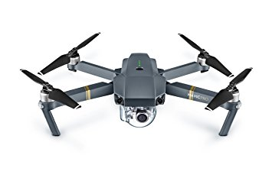 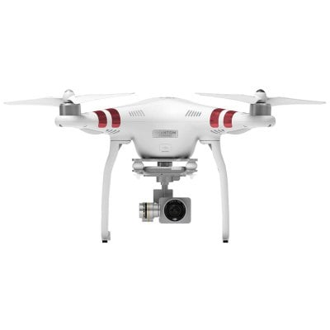v

(Fig 1: DJI Drone Mavic Pro) (Fig 2: DJI Phantom 3)

**Proposal Form:**

**Project Title:** R.Pi Quad_X

**Purpose:**

The purpose of this Project is to build a chrome to be controlled remotely from mobile phone.

**Customer Feature List:**

The Customer will be able to control the Drone by using a Smartphone to send commands and control the Drone and provide entertainment for the end user. The Customer will be able to fly a quadcopter over a long range in an open space environment. Major features include Wi-fi and possibly over Bluetooth. Major features include:

1. Quadcopter control
2. Smartphone interface
3. Rotation
4. Hovering
5. Spinning

**Context Diagram:**

**System**

Throttle

All Motors in increase speed gradually.

Diametrically opposing pairs of motors increase their speed relative to the other pair.

Yaw

Pitch

Roll

Speed of the right motors increase relative to the left

Rear Motors increase relative to the Motors in front.

|  |  |  |  |
| --- | --- | --- | --- |
| **Name** | **Direction** | **Type** | **Description** |
| Yaw | Input from Smartphone | Digital/Network | Controlling Altitude of the Drone by receiving instructions from Smartphone to the Raspberry which will instruct the Multi-Wii Flight Controller to twist or oscillate about a vertical axis. |
| Pitch | Input from Smartphone | Digital/Network | Controlling of the Drone by receiving instructions from Smartphone to the Raspberry which will instruct the Multi-Wii Flight Controller to move the Drone’s nose up or down about an axis running from wing to wing. |
| Throttle | Input from Smartphone | Digital/Network | Controlling of the Drone by receiving instructions from Smartphone to the Raspberry which will instruct the Multi-Wii Flight Controller to rotate the Quadcopter Clockwise or Counter clockwise. |
| Roll | Input from Smartphone | Digital/Network | Controlling of the Drone by receiving instructions from Smartphone to the Raspberry which will instruct the Multi-Wii Flight Controller to rotate the copter from front to back. |
| Front Motors | Output from the Quadcopter | Analog | Rear Motors increase relative to the Motors in front when the Pitch input is applied. |
| Motor Speed Right | Output from the Quadcopter | Analog | Speed of the right motors increase relative to the left when the Roll input is applied. |
| Cloud Service | Output | Digital | Cloud storing input Data that passes from the Smartphone to the Raspi |

Hence each individual Motors provide different results when they rotate in a pair relatively faster to the other whether it is the Motors rotating diagonally rotating or next to each other.

**What will my Project depend on?**

My Project will depend on its performance and its processing power that will distribute the necessary properties to each of the 4 Motors. It will also depend on the connectivity such as the input signals that is passed from the Smartphone. The input signals that is transferred to the Quadcopter aircraft will play a powerful factor because it varies on the amount of bandwidth connection to measure the response-time of the Drone when the input signal is passed.

**Non-Functional Requirements:**

1. The Motors that will be used in the Drone must be battery powered.
2. The communication will be Wireless which means the data being sent to the receiver (The Raspberry Pi and then to the Multi-Wii Flight Controller) will depend on the Bandwidth connection and range from the Smartphone to the Wi-Fi Adapter that is connected to the Pi acting as the receiver.

**Concepts Used:**

I will be using other skills from what I learned in other modules such as Discrete Mathematics (Logic), Computer Systems, Physics, Programming Fundamentals.

**Technology/Tools:**

1. x4 PCs 1045 Propellers
2. x4 A2212/13T 1000KV Brushless Motors
3. DJI F450/F550 Quadcopter Multirotor Kit Frame Broaden & x4 Pcs Landing Gear Skids
4. Rechargeable 11.1V 25-35C Turnigy High Discharge 2200mAh Lipo Battery
5. Multi-Wii Standard Flight Controller
6. x4 ESC Brushless Motor Speed Controllers BEC 3A Accessory
7. Raspberry Pi 3 Model B
8. Power Distribution Board
9. Android Application
10. Soldering Equipment
11. Screws
12. Laptop
13. Zip ties.

**Functional Specifications:**

**Purpose:**

The purpose of this Project is to build a drone to be controlled remotely from mobile phone.

Project Plan of the Subsystems put together (How my Quadcopter will fly):

# Diagram of Quadcopter working Mechanism:

**M2**

**M1**

Quadcopter Drone

**ESC**

**ESC**

Smartphone input signals

**Multi-Wii**

**Raspberry Pi**

**PWD**

**Abbreviations:**

**ESC**

**ESC**

1. **ESC** = Electronic Speed

**Lipo-Battery**

**M4**

**M3**

Controllers.

1. **PWD** = Power Distribution

Board.

1. **M** = Motor (Brushless Motors)

**Propulsion:**

Two of my motors will spin clock-wise (Motor 1 and Motor Motor 4) and the other two counter clock-wise (Motor 2 and Motor Motor 3)

# Subsystem 1 (Power Subsystem)

**Name: Power Subsystem**

**Description:**

This is basically everything that will make my quad fly. A large percentage of the higher-end of the battery powers this subsystem. The flight/power system contains the following:

* Frame
* Motors
* Electronic Speed Controllers (ESCs)
* Power distribution (whether it’s a power distribution board or a power harness)
* Propellers
* Batteries

**Inputs:**

* Voltage power that is generated by the battery

**Outputs:**

* Motor rotates accordingly

# Subsystem 2 (Radio Transmitter/Receiver/Flight Controller Subsystem)

**Name: Radio Transmitter/Receiver/Flight Controller Subsystem (Software that flies the Quadcopter)**

**Description:**

This is the system that I will use to control the copter. It’s the transmitter and the receiver that the controller communicates with that sits on the actual copter.

* Smartphone (Transmitter)

**Inputs:**

* Yaw (Digital/Network Input which will be from the Smartphone)
* Pitch (Digital/Network Input which will be from the Smartphone)
* Throttle (Digital/Network Input which will be from the Smartphone)
* Roll (Digital/Network Input which will be from the Smartphone)

**Outputs:**

* Sends out the instructions to Raspberry Pi
* Raspberry Pi (Receiver)

**Inputs:**

* Instructions are received by the Wi-Fi Dongle or in-built wifi which now acts as a router for the smartphone to connect to.

**Outputs:**

Passes the instructions to the Multi-Wii using a USB cable to transfer serial connection to the Pi. This allows the Pi to simulate radio input without using the normal radio input pi.

* Multi-Wii (Flight Controller)

**Description:** The specific brand of flight controller being used. A flight controller is a small board whose function is to direct the RPM of each motor. It is too complicated to control each motor of a Mult-icopter individually. So, a flight controller responds accordingly to (roll, pitch, yaw, throttle) input from the pilot, calculating how to direct the motors.

**Inputs:**

* Instructions are received from the Pi through a USB to a FDTI serial connection to the Pi. This allows the Pi to simulate radio input without using the normal radio input pi.

**Outputs:**

* The instructions are then determined and processed on the Multi-Wii and sent out to direct the Motors through the Pins of the Multi-Wii Board and through the ESCs.

# Subsystem 3 (Support Subsystem)

**Name: Support Subsystem (Frame)**

**Description:**

The support subsystem is everything on the ground that will use to keep my quad-copter back up in the air. I’m going to crash and possibly break things, so having a good support system is worth it.

DJI F450/F550 Quadcopter Multirotor Kit Frame Broaden (Frame)

**Inputs:**

* Instructions are received from the Pi through a USB to a FDTI serial connection to the Pi. This allows the Pi to simulate radio input without using the normal radio input pi.

**Outputs:**

* Holds everything in place using zip ties

Subsystem 4 (Drone Monitoring in the Cloud)

**Name:** Monitoring Drone Movements in the Cloud

**Description:**

Whatever movements the Drone makes, it will be rendered in the cloud using the Adafruit for Raspberry Pi Service and it can be seen on any Desktop interface or Laptop. In my final built I didn’t get it to work with AdaFruit due to the time I had, but I was able to view the input Signals on the terminal of the Raspberry Pi as the Quadcopter was armed.

**Outputs:**

* Displays the data of motor movements, whether its moving left or right in graphs.

Next are the screenshots of over my PowerPoint Presentation of my Project that I presented in the class during the Semester.

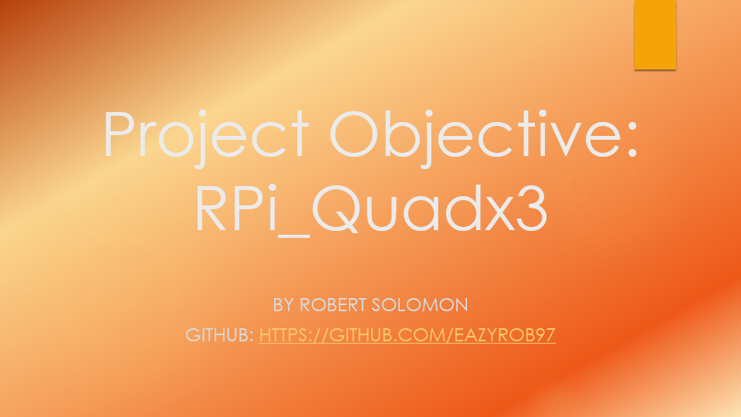

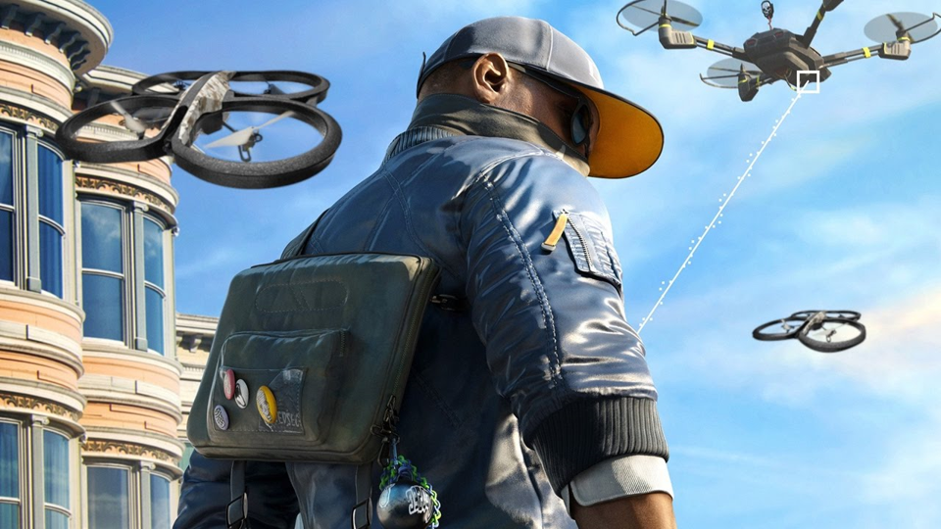

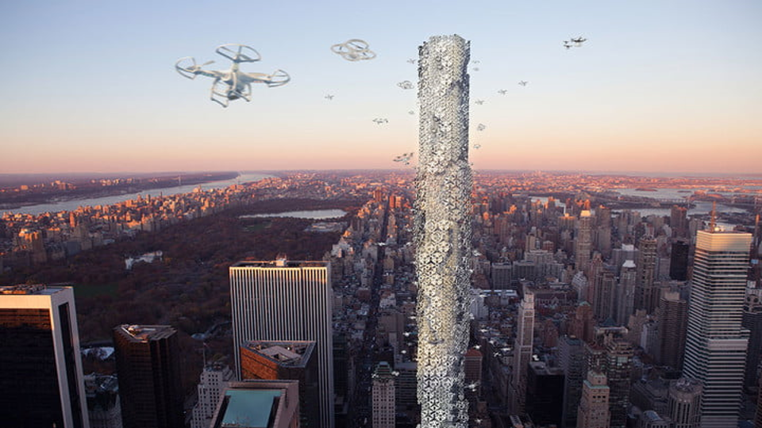

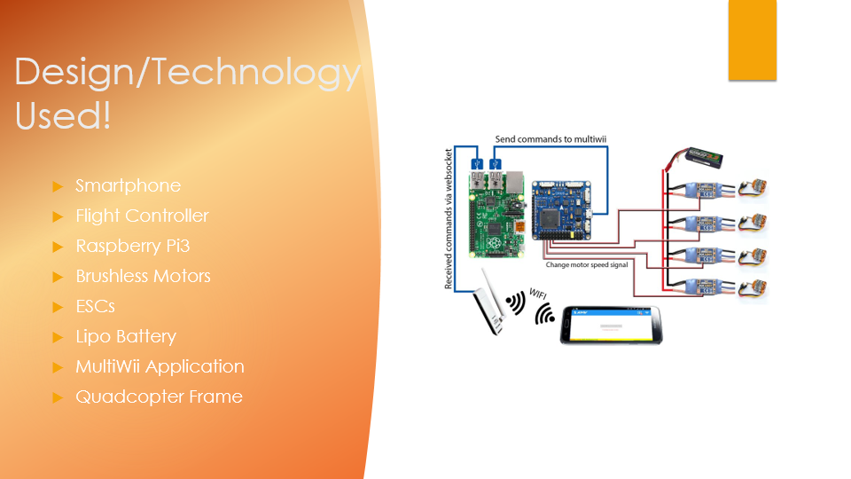

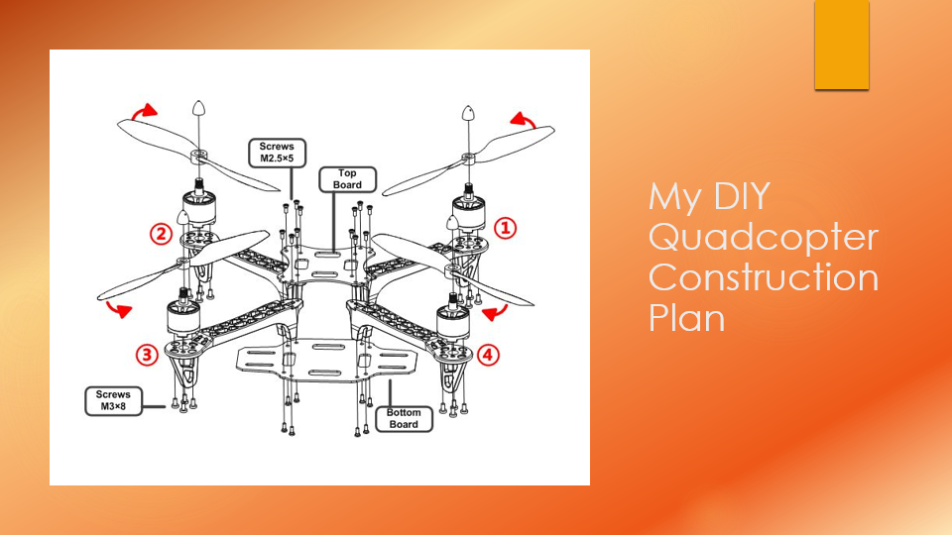

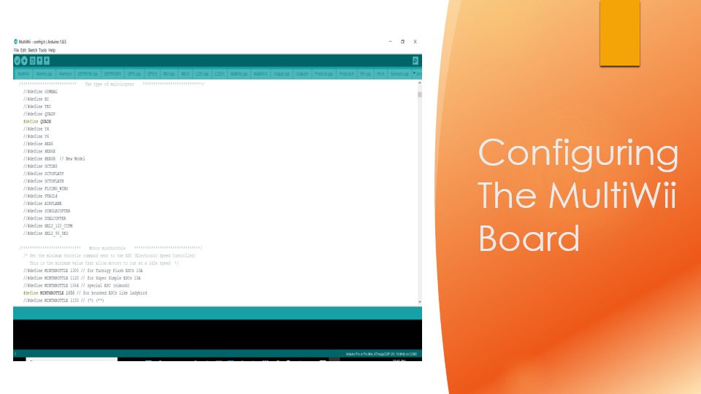

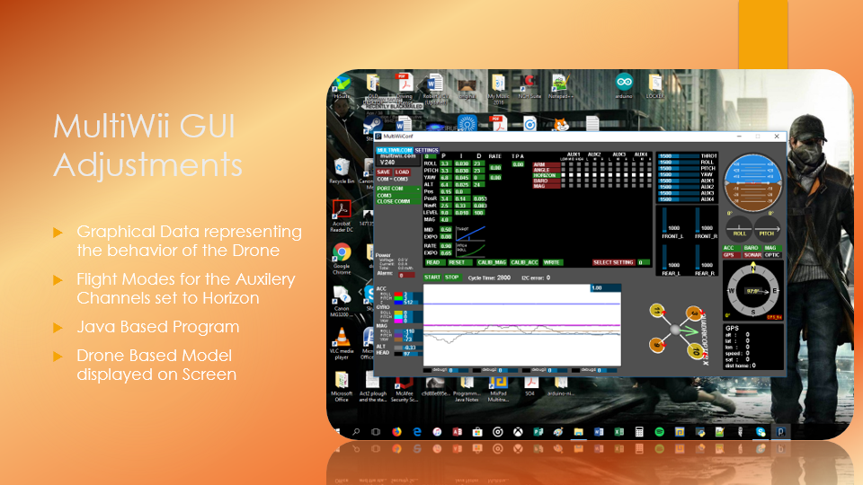

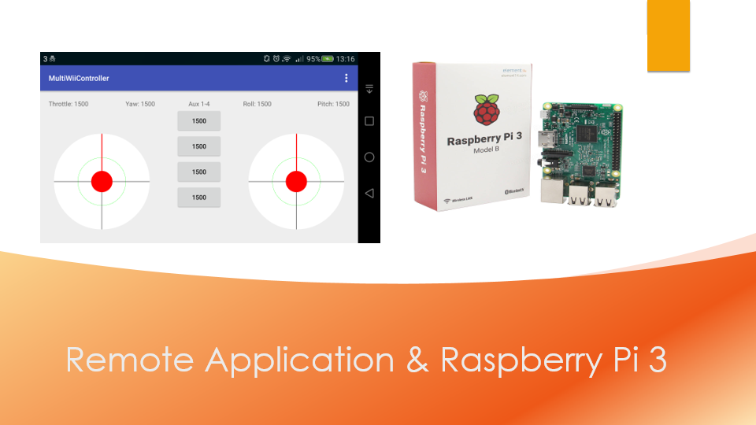

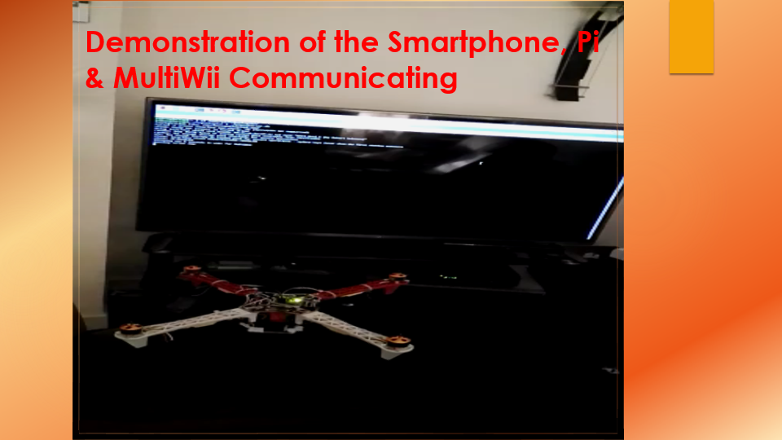

(You must click on the video file below because the one above is merely a screenshot because it didn’t import it as a video)



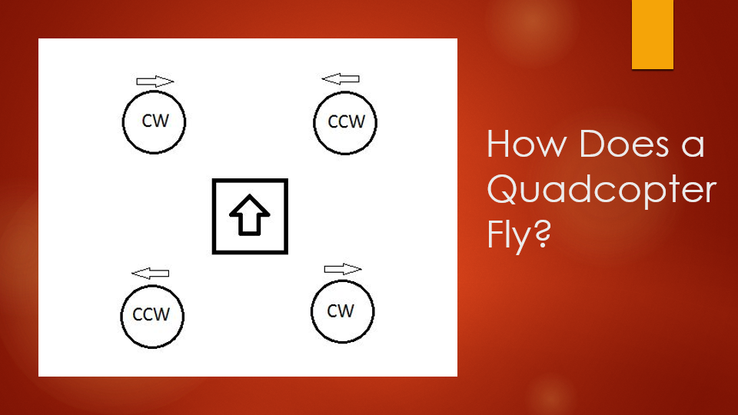

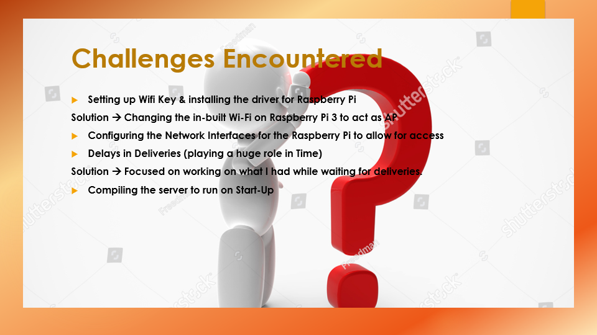

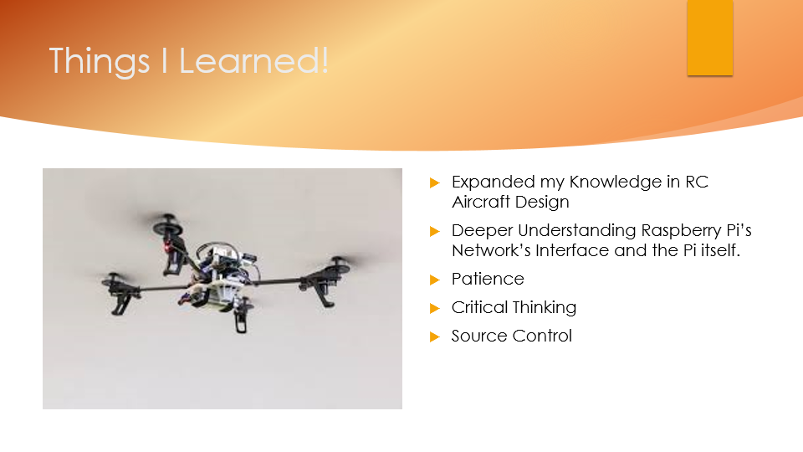

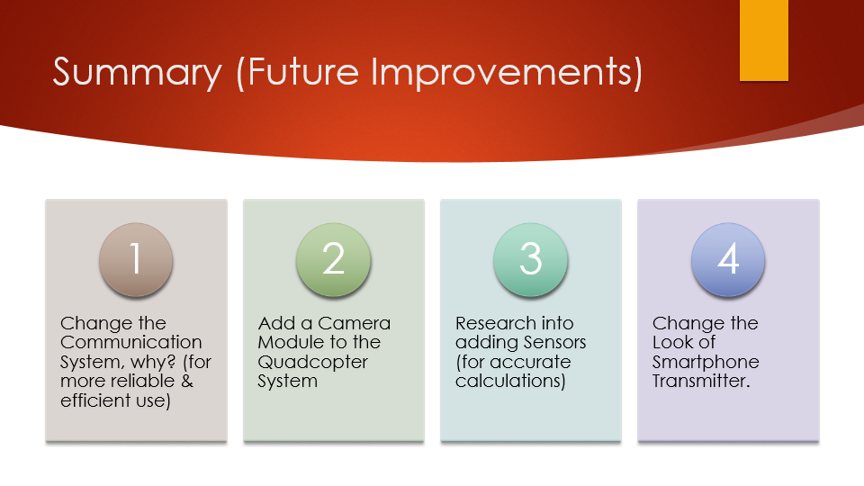



**Usage of Drones:**

* 1. A Drone is mostly used for surveillance by the police & Military purposes.
  2. A Drone can be used to watching city streets.
  3. Drones can be used for medical purposes and it helps spot areas where there could be for e.g. Road Accidents
  4. A Drone can be used for Transport Services where it is either piloted or unmanned.

There are many things a Drone can be used for if it has the right capabilities, processors and hardware equipment’s to do so.

**Future of the Drones:**

New Applications are coming into picture as the work efficiency and tolerance capacity of the drones have surpassed all expectations. Recently in India has also joined the bandwagon by releasing its own Drones over the past years. We can use our drone attached with a camera for surveillance of the WIT Campus or anywhere necessary if that were to be a case of an improvement in my drone. It is something that looking to work on in the future. Another one that I belive, needs to be improved is the communication system between the Device sending the commands to the receiver that is listening and waiting for a command in which I mentioned in my Presentation. I’m looking to use a Radio communication system which is commonly used and known across the Drone and RC Aircraft Community. This will be my next Goal to achieve in which I’m planning as for the upcoming Summer of 2018. I’m also in the process of designing a Website for People or experienced People to come and view or check out to see how I came to do it. It is not finished yet as it is still under development. The link for it is not yet decided but it will be included in on my GitHub in the future so do keep an eye out. My GitHub Account Name is ‘EAZYROB97’.

**Conclusion:**

It has been a tremendous journey this Semester and it was well worth it, although it took a lot of time to plan and think on what I was to going to choose to do for my Project. I wanted to not only make it mean something for People but for myself. It has been something that I’ve always been interested in doing. In saying this I hope it will also encourage People in to get into the hobby of Drone Building, Drone Racing or just for experience, I can tell you that it is quite fun, and it provides you with more and more ideas as it is never ending. There is always something to improve and try. It is what Project Module and the Project has thought me to keep striving for great things and trying things out.